As a customer I want to see what products are available at the school shop and be able to place an online order that will give me information about its progress.

As a shop manager I want to be able to see the placed orders, edit them and their stage of fulfilment. The customers need conformation of the order.

I will do this by creating a product object. This will then be linked to an intermediary object that will allow the customer to add a quantity to the order and all the relevant methods. This intermediary object will be linked to order in a basket.

I have learnt the method of using intermediaries for complex tasks that cant be accomplished by a direct relationship. How to have default values for user interface options and the importance of formatting the user interface for easy use.

Below are the new objects and the user interface:

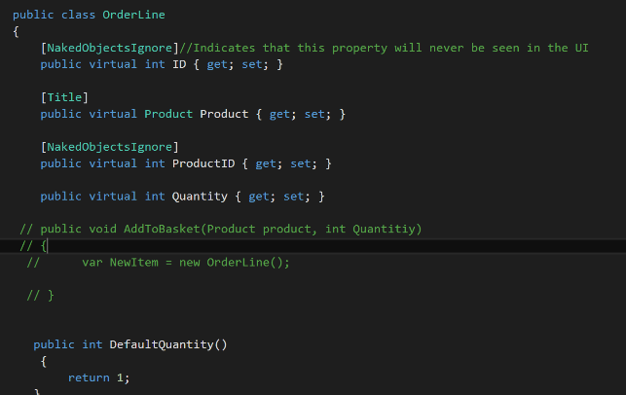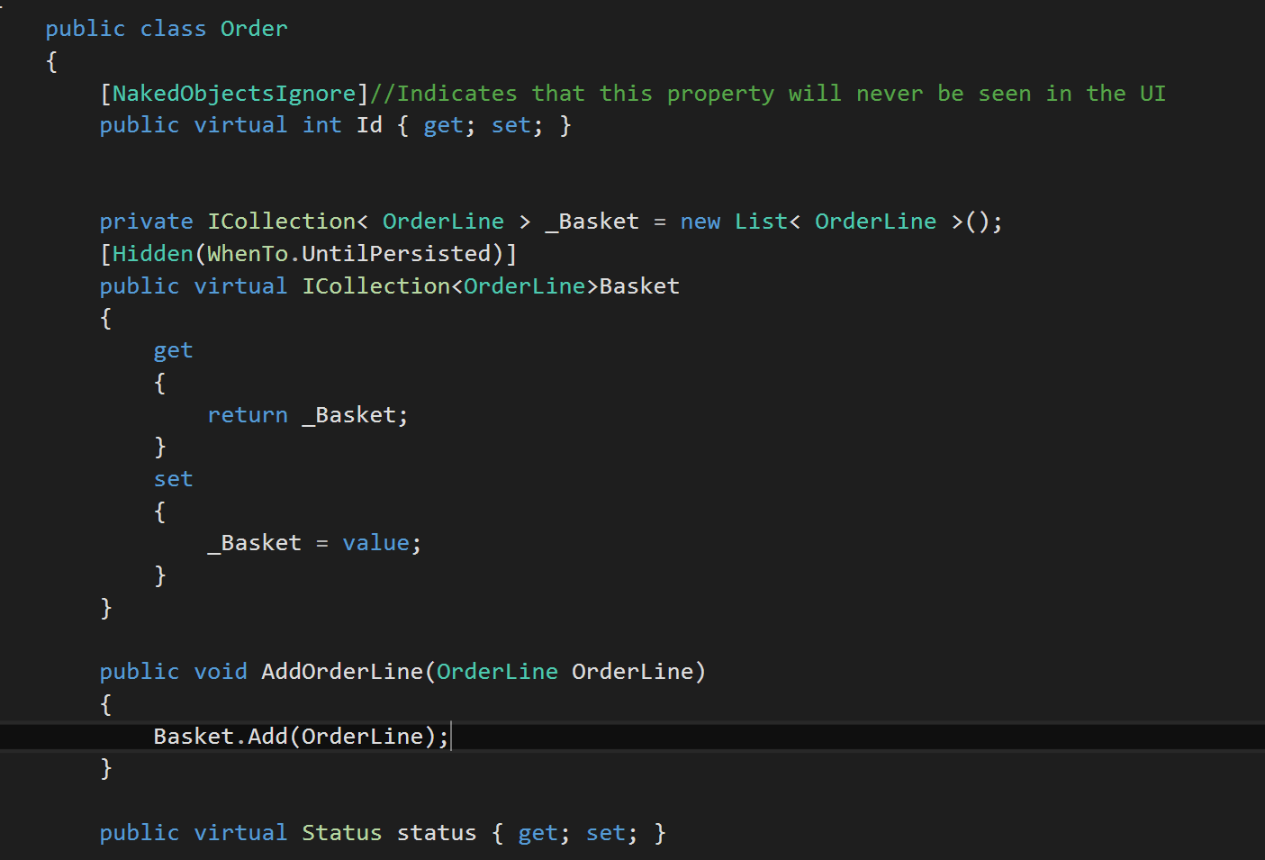



**I met the** objectives for this iteration. In future iterations I hope to make the system more user friendly by integrating the orderline so the user doesn’t have to use it manually.